Team Details :

Team# Group-305

S. No | Name | BITS ID | Contribution | Comment
1 | Saranya A | 2024AD05155 | 100%
2 | Rajasekaran | 2024AD05043 | 100%
3 | Anchal Singh | 2024AC05960 | 100%
4 | Nithin Shetty | 2024AC05121 | 100%
5 | Umang Sharma | 2024AC05070 |  | Not responsive

PART – A

A.1 Theoretical Components:

Explain the PEAS (Performance measure, Environment, Actuator, Sensor) for your agent.
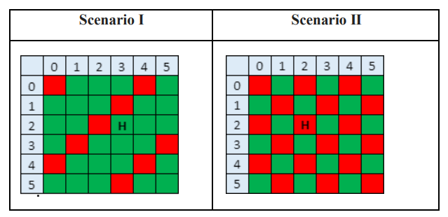

Component | R1 Agent | G1 Agent
Performance Measure | Reach the goal node "H" with minimal cost. Cost is calculated as: Transition cost (1 per move) + penalties for entering red/green zones (green: +10, red: -10). | Same goal: reach node "H" with minimal cost. Penalties are reversed (green: -10, red: +10).
Environment | 6x6 grid with colored cells: red, green, and neutral. Static environment (doesn't change during the run), fully observable, deterministic. | Same 6x6 grid with obstacles and goal node.
Actuators | Movement in 4 directions (up, down, left, right) per grid cell. | Same set of actuators as R1.
Sensors | Detect cell color (green/red), current position, and location of goal node "H". | Detect cell color (green/red), current position, and location of goal node "H".

A.2 Output Screenshot:

